# AI Assisted Coding – Assignment 3.1

Course Code - 24CS002PC215

Course Title - AI Assisted Coding

Year / Sem - II / I (2 – 1)

Regulation - R24

Date: 24-08-2025

Student Name: G.Sanjansah

Hall Ticket Number: 2503a52l20

Student Mail-ID : [2503a52l20@sru.edu.in](mailto:2503a52l20@sru.edu.in)

## Prompt Engineering – Improving Prompts and Context Management

# Screenshot 1 :

# Screenshot 2 :

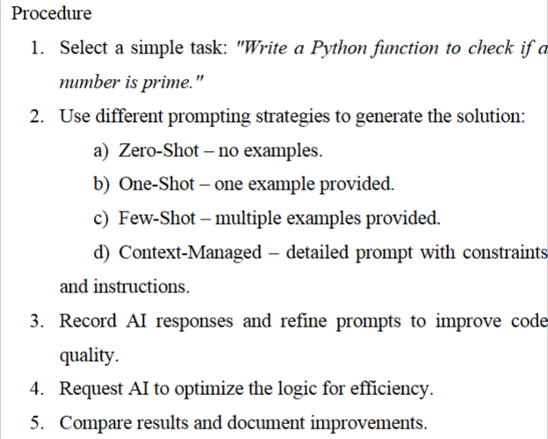

A) Zero Shot example:

B) One Shot example:

C) Few Shot example:

# Mobile Data Usage Billing Application :

# Screenshot 1 :

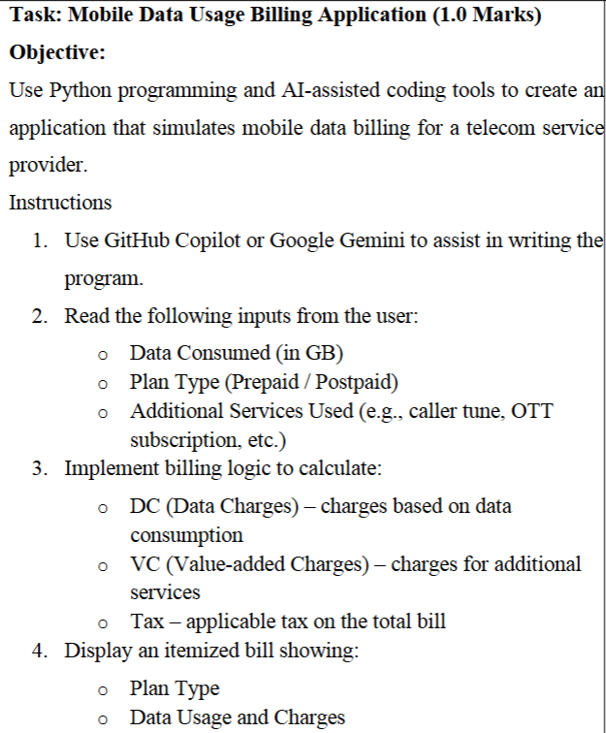

# Screenshot 2 :

# Screenshot 3 :

# Screenshot 4 :

# Screenshot 5 :

# Screenshot 6 :

# LPG Billing System :

# Screenshot 1 :

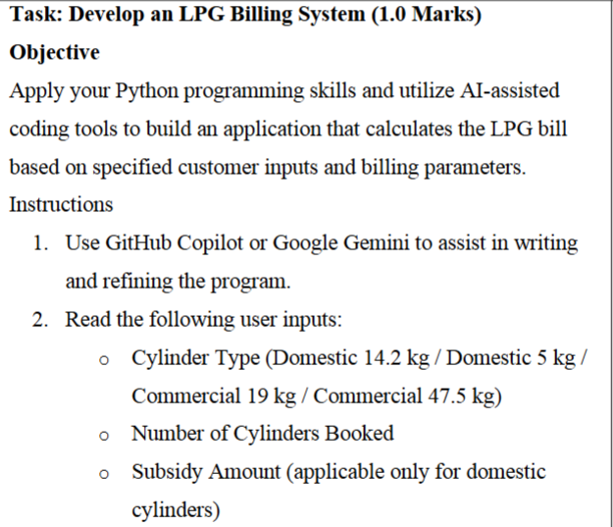

# Screenshot 2 :

# Screenshot 3 :

# Screenshot 4 :

# Screenshot 5 :

# Screenshot 6 :

